A

Mini-Project Report on

**Web-based job searching portal**

Submitted in partial fulfillment of the requirements for the degree of

BACHELOR OF ENGINEERING

IN

### Computer Science & Engineering

### Artificial Intelligence & Machine Learning

by

Aabha Bhide - (22106093)

Sudhiksha Aradhyula - (22106010)

Aditi Gadhave - (22106079)

Niharika Bandekar - (22106136)

Under the guidance of

## Prof. Mahesh Pawaskar



### Department of Computer Science & Engineering

### (Artificial Intelligence & Machine Learning)

**A. P. Shah Institute of Technology**

**G. B. Road, Kasarvadavali, Thane (W)-400615**

**University Of Mumbai**

**2023-2024**

## A. P. SHAH INSTITUTE OF TECHNOLOGY

## CERTIFICATE

This is to certify that the project entitled **“Web-based job searching portal”** is a bonafide work of Aabha Bhide (22106093), Sudhiksha Aradhyula (22106010), Aditi Gadhave (22106079) and Niharika Bandekar (22106136) submitted to the University of Mumbai in fulfillment of the requirement for the award of **Bachelor of Engineering** in **Computer Science & Engineering (Artificial Intelligence & Machine Learning).**

|  |  |
| --- | --- |
| ________________ | _______________ |
| Prof. Mahesh Pawaskar | Dr. Jaya Gupta |
| Mini Project Guide | Head of Department |

## 

## A. P. SHAH INSTITUTE OF TECHNOLOGY

## Project Report Approval

This Mini project report entitled **“Web-based job searching portal*”*** by **Aabha Bhide, Sudhiksha Aradhyula, Niharika Bandekar and Aditi Gadhave** is approved for the degree of ***Bachelor of Engineering*** in ***Computer Science &Engineering***, (AIML) ***2023-2024***

##### External Examiner:

##### Internal Examiner:

Place: APSIT, Thane

Date:

**Declaration**

##### We declare that this written submission represents my ideas in my own words and where others' ideas or words have been included, I have adequately cited and referenced the original sources. I also declare that I have adhered to all principles of academic honesty and integrity and have not misrepresented or fabricated or falsified any idea/data/fact/source in my submission. I understand that any violation of the above will be cause for disciplinary action by the Institute and can also evoke penal action from the sources which have thus not been properly cited or from whom proper permission has not been taken when needed.

|  |  |  |  |
| --- | --- | --- | --- |
| Sudhiksha Aradhyula | Aditi  Gadhave | Aabha  Bhide | Niharika  Bandekar |
| (22106010) | (22106079) | (22106093) | (22106136) |

#### ABSTRACT

This project aims to develop a specialized job finding website tailored to the needs of new mothers returning to the workforce after having a baby. The website will provide a user-friendly interface with comprehensive job listings, including remote, part-time, flexible, and work-from-home opportunities suitable for new moms. Users will be able to access resources and support for resume building, interview preparation, and childcare options. Community features such as webinars will facilitate connections among new moms, while company profiles will highlight organizations with family-friendly policies. The platform will prioritize user privacy and security and will be mobile-compatible for convenient access. Through partnerships with relevant organizations and companies, the website aims to empower and support new moms as they navigate the transition back to work while caring for their families.

**Index**

|  |  |  |  |
| --- | --- | --- | --- |
| Index | | | Page no. |
| Chapter-1 | | | 1 |
|  | Introduction | |  |
|  |  |  |  |
| Chapter-2 | | | 4 |
|  | Literature Survey | |  |
|  | 2.1 | Literature Survey |  |
|  | 2.2 | Limitations |  |
| Chapter-3 | | | 9 |
|  | Problem Statement | |  |
|  |  |  |  |
| Chapter-5 | | | 11 |
|  | Implementation | |  |
|  | 5.1 | Implementation |  |
|  | 5.2 | Screenshots |  |
|  |  |  |  |
| Chapter-6 | | | 17 |
|  | Conclusion | |  |
|  |  |  |  |
| References | | | 19 |
|  |  |  |  |

# CHAPTER 1

# INTRODUCTION

### INTRODUCTION

A nurturing space designed specifically for resilient and talented mothers returning to the workforce after maternity leave. We understand the unique challenges that come with balancing the demands of motherhood and a professional career, and we are here to support you in your journey to re-enter the workforce.

We recognize the incredible skills and experiences that mothers bring to the table. Our web-based job searching portal is tailored to cater to the specific needs of moms who are ready to reignite their careers. We believe that motherhood enhances your skill set, bringing unparalleled qualities such as adaptability, multitasking, and exceptional time management.

The following are a few features of our website:

Flexible Opportunities: Explore a wide range of flexible job opportunities that accommodate your schedule and allow for a healthy work-life balance. We partner with companies that value and embrace flexible work arrangements.

Skill Showcasing: Showcase not only your professional experience but also the valuable skills gained through motherhood. Our platform allows you to highlight your adaptability, problem-solving abilities, and effective communication skills that are often honed during maternity leave.

Career Development Resources: Access resources specifically curated to assist mothers in their career development journey. From resume tips tailored for employment gaps to interview strategies that emphasize your strengths, we provide the tools you need to succeed.

Employer Understanding: Partnering with companies that recognize and appreciate the value of hiring mothers, we strive to create a bridge between your skills and employers who embrace diversity and inclusion in the workplace.

Empowering Workshops and Events: Participate in workshops and events designed to empower and uplift working moms. Gain insights from successful women who have successfully navigated the transition back to the workforce after maternity leave.

We celebrate the strength, resilience, and unique skills that mothers bring to their professional lives. Your journey back to the workforce should be as rewarding as your role as a mother. Join us, where we understand and support the extraordinary journey of moms returning to work. Your next fulfilling career chapter awaits!

# CHAPTER 2 LITERATURE SURVEY

#### 2.1 LITERATURE SURVEY

1) One explanation for the gender pay differences in labor markets is that women propose lower desired salaries. By using an actual job seeking resume database and applying text mining techniques, we are able to observe both the extent of gender differences in desired salaries and job-related self-view. We find gender differences in global self-view favoring females, and in some domain-specific self-view favoring males. Previous findings of disadvantaged groups having levels of self-view at least as high as those of advantaged groups lend credibility to our findings. Moreover, we argue that the differences in global self-view favoring females may be related to the theories of “belief flipping”, since women in our sample of online-recruitment markets are distinct from the general population, with on average 15.2 years of education and 8.99 years of work experience, due to self-selection. [1]

2) Based on a job marketing approach to the recruitment process and consumer behaviour research on persuasive communication and decision making, we present considerations important to creating an online recruiting website that effectively influences the search decisions and behaviours of a target market of desired job candidates. Clearly, Internet recruitment methods represent a growing and high-potential opportunity for employers to broaden their recruiting reach and reduce recruiting costs.[2]

3) Women earn better grades than men across levels of education—but to what end? This article assesses whether men and women receive equal returns to academic performance in hiring. I conducted an audit study by submitting 2,106 job applications that experimentally manipulated applicants’ GPA, gender, and college major. Although GPA matters little for men, women benefit from moderate achievement but not high achievement. As a result, high-achieving men are called back significantly more often than high-achieving women—at a rate of nearly 2-to-1. I further find that high-achieving women are most readily penalized when they major in math: high-achieving men math majors are called back three times as often as their women counterparts. A survey experiment conducted with 261 hiring decision-makers suggests that these patterns are due to employers’ gendered standards for applicants. Employers value competence and commitment among men applicants, but instead privilege women applicants who are perceived as likeable.[3]

4) Data from a national survey of new mothers are used to examine class and labour market differences in women's labour market opportunities after childbirth. Women's labour market intentions during pregnancy are brought into the analysis in order to examine class and labour market effects on securing a desired outcome. Substantially unequal rates of returning to work are shown to exist and to have persisted over the last decade among women with occupations in different social classes. Examining the relationship between women's employment intentions during pregnancy and their labour market outcomes after childbirth confirmed the importance of class position. One implication of the research is that there is likely to be increased polarization of advantage and disadvantage among women in the labour market, and among families in general.[4]

5) The analysis unveils three major findings. First, 80.74% of variations in female employment are accounted by e-commerce and control variables. Second, Autoregressive Distributed Lag analysis documents that these series (female employment, e-commerce and control variables) are cointegrated, thus, a unit increase in per credit card e-commerce transactions leads the female employment rate to grow by 0.13 units in long-run at 1% significance level, whereas a percentage increase in internet penetration rate in Turkey augments the rates by 0.33%. Third, error-correction model analysis refers that the system quickly corrects its previous period disequilibrium converging at a speed of 75.43%, and also documents that the lags of per credit card e-commerce jointly have short-run impact on female employment rates.[5]

**2.2 LIMITATIONS**

While web-based job searching portals for moms after maternity leave provide a valuable resource, they are not without their limitations. Identifying these limitations is crucial for ongoing improvement and development. Here are some potential limitations:

Limited Flexibility in Job Listings:

Many job portals may not offer a diverse range of flexible work arrangements suitable for mothers. The limited availability of part-time, remote, or flexible positions can hinder moms seeking options that accommodate their family responsibilities.

Lack of Personalization:

Some portals may not provide sufficient resources specifically tailored to the unique needs and challenges faced by mothers returning to work. Comprehensive guidance on addressing career gaps, showcasing parenting skills on resumes, and navigating the return-to-work process may be lacking.

Inadequate Support for Skill Recognition:

The platforms may not effectively highlight the transferable skills gained during maternity leave. Recognizing and showcasing the valuable skills developed during this time is essential for successful career re-entry.

Insufficient Employer Education:

Employers may not be adequately educated on the benefits of hiring returning mothers. Portals may need to focus on employer education to promote a more inclusive hiring culture and dispel biases against candidates with career gaps.

Data Privacy and Security Concerns:

Job portals deal with sensitive personal information. If the platform lacks robust security measures, moms may be hesitant to share their details, which could limit the effectiveness of the portal in connecting them with suitable opportunities.

Limited Representation of Mom-Friendly Companies:

Some portals may not have a sufficient number of companies committed to providing mom-friendly workplaces. This limitation could result in fewer opportunities for mothers seeking organizations with family-friendly policies.

Accessibility Challenges:

Web-based platforms may not be accessible to all moms, particularly those with limited access to technology or those facing socio-economic barriers. This limitation can exclude a significant portion of the target audience.

# CHAPTER 3

# Problem Statement

#### 3.PROBLEM STATEMENT

The challenge of mothers re-entering the workforce after maternity leave is underscored by a lack of specialized support mechanisms, hindering their seamless integration into professional life. Current job searching portals often overlook the unique needs of mothers, failing to provide tailored resources, flexible opportunities, and a supportive community. The absence of such a dedicated platform exacerbates the difficulties faced by mothers in navigating job opportunities, contributing to a significant gap in their successful return to the workforce. This problem statement emphasizes the critical need for a web-based job searching portal specifically designed to address the distinct challenges and aspirations of mothers after maternity leave, aiming to bridge the existing gap and empower their professional re-engagement.

We are creating a job platform specifically for women seeking to return to work after taking maternity leave. The platform will connect women with employers offering flexible work hours, remote options, and family-friendly policies. We have partnered with organizations to provide access to flexible schedules. We also offer health benefits packages, including 2 free annual check-ups for women who get jobs through our platform. Additionally, we host seminars on topics like women's empowerment, transitioning back to work postpartum, and work-life balance for mothers. By providing a supportive community, relevant resources, and family-friendly job opportunities, we aim to help women successfully relaunch their careers after starting a family

# CHAPTER 4

# Implementation

#### 4.1 IMPLEMENTATION

Implementing the job finding website for new moms involves several stages, from planning and development to launch and maintenance. Here's a step-by-step guide to implementing the project:

* **Market Research and Planning:**

Conduct market research to identify the needs and preferences of new moms returning to the workforce.

Define the target audience, key features, and unique selling points of the job finding website.

Develop a business plan outlining the project's goals, revenue model, and timeline for implementation.

* **Website Development:**

Choose a reliable web development platform or hire a team of developers to build the website.

Design the user interface (UI) and user experience (UX) of the website, ensuring it is intuitive and easy to navigate.

Implement core features such as job listings, user profiles, search functionality, and job alerts.

Integrate additional features such as forums, networking tools, and resources for new moms.

* **Content Creation and Curation:**

Curate a database for our portaal suitable for new moms, including remote, part-time, and flexible opportunities.

* **Testing and Quality Assurance:**

Conduct thorough testing of the website to identify and fix any bugs, errors, or usability issues.

Test the website's compatibility with different devices, browsers, and screen sizes to ensure a seamless user experience.

Solicit feedback from beta testers, focus groups, or early adopters to gather insights and make improvements.

* **User Acquisition and Engagement:**

Implement strategies to attract new users to the website, such as offering incentives for signing up or referring friends.

Foster a sense of community by encouraging user interaction through forums, networking events, and support groups.

Provide personalized recommendations and job alerts based on users' preferences and interests.

Collect user feedback and suggestions to continuously improve the website and enhance the user experience.

* **Maintenance and Updates:**

Regularly monitor the website for performance issues, security vulnerabilities, and outdated content.

Update the job listings, resources, and features regularly to keep the website relevant and up-to-date.

Stay informed about industry trends and changes in the job market to adapt the website's offerings accordingly.

Provide ongoing customer support and assistance to address user inquiries, concerns, and feedback.

**4.2 SCREENSHOTS**

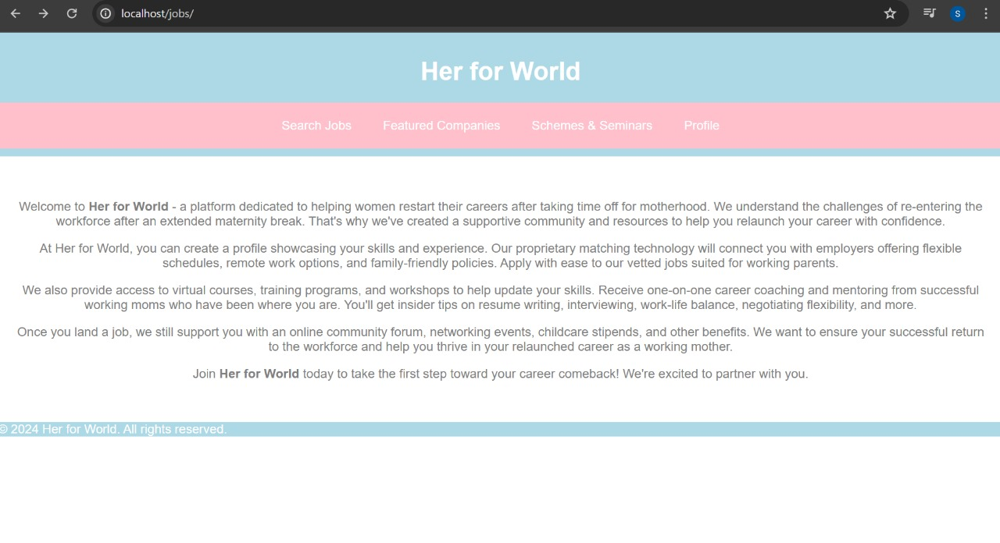

Figure 4.1: Front page of the website

This is the front page of the website. A little information on the whereabouts are given about the website.

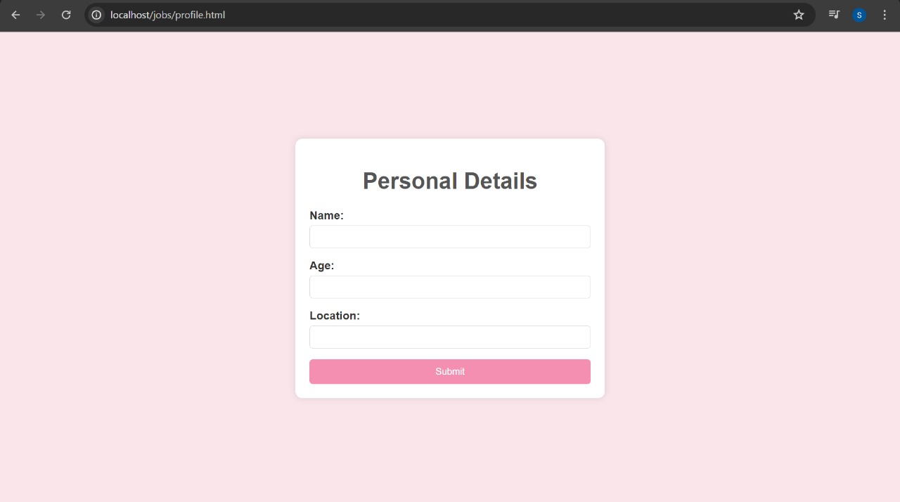

Figure 4.2: Page connected to the database

This is the page which is connected to the database.

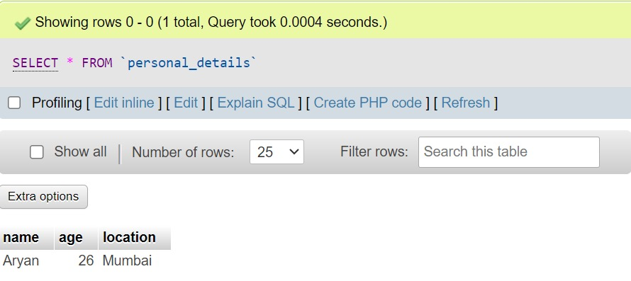

Figure 4.3: Database

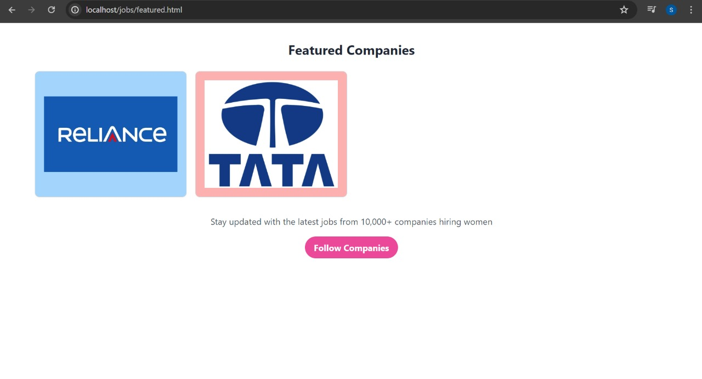

Figure 4.4: Featured companies page in website

Examples of the featured companies available on the portal.

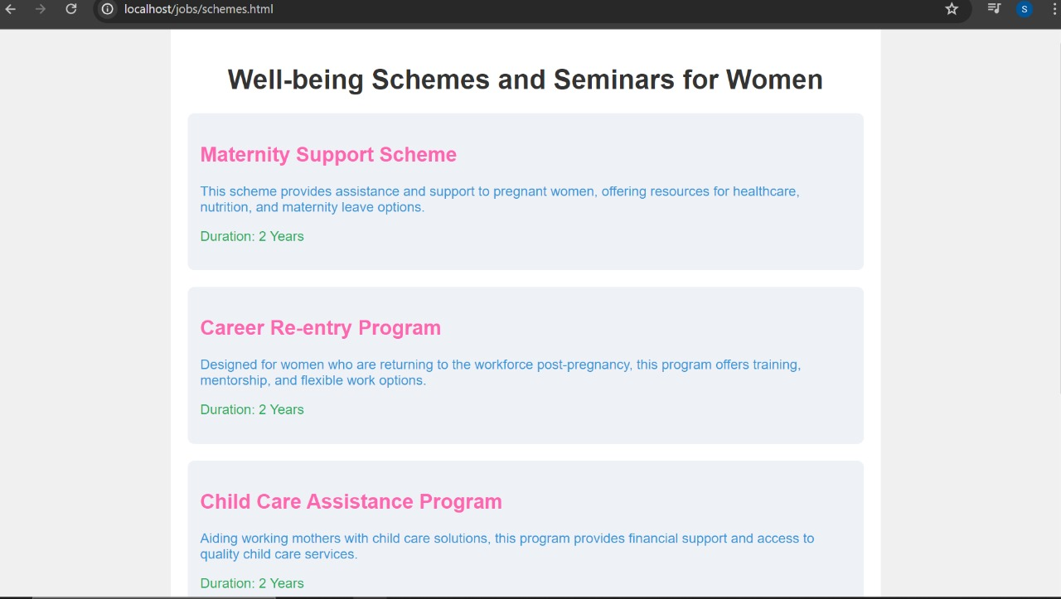Figure 4.5: Schemes section of the websites

Schemes section.

# CHAPTER 5

# Conclusion

**5. CONCLUSION**

We are creating a job platform specifically for women seeking to return to work after taking maternity leave. The platform will connect women with employers offering flexible work hours, remote options, and family-friendly policies.

We have partnered with organizations to provide access to flexible schedules. We also offer health benefits packages, including 2 free annual check-ups for women who get jobs through our platform.

Additionally, we host seminars on topics like women's empowerment, transitioning back to work postpartum, and work-life balance for mothers. By providing a supportive community, relevant resources, and family-friendly job opportunities, we aim to help women successfully relaunch their careers after starting a family.

# References

**Research paper**

[1] Zhang, Xiaoqi, and Yanqiao Zheng. "Gender differences in self-view and desired salaries: A study on online recruitment website users in China." PLoS One 14, no. 1 (2019): e0210072.

[2]Madera, Juan M. "Using social networking websites as a selection tool: The role of selection process fairness and job pursuit intentions." International Journal of Hospitality Management 31, no. 4 (2012): 1276-1282.

[3]Quadlin, Natasha. "The mark of a woman’s record: Gender and academic performance in hiring." American Sociological Review 83, no. 2 (2018): 331-360

[4]McRae, Susan. "Returning to work after childbirth: opportunities and inequalities." European sociological review 9, no. 2 (1993): 125-138.

[5] Sovbetov, Yhlas. "Impact of digital economy on female employment: Evidence from Turkey." International Economic Journal 32, no. 2 (2018): 256-270.